Bridging the Income Gap in Singapore
Nanyang Technological University
CC0006 Sustainability
Dr Swati Sharma, Mr Jeffrey Hong Yan Jack
18 November 2022
Group 13 (Chinese Broccoli)
Roy Kang (U2122876A), Damien Tan (U2140002L), Ianette Lim (U2123721G), Lim Jia Rei (U2130618K), Ng Ping Boon (U2140264H)

Abstract
This report provides a comprehensive review of the income inequality in Singapore, focusing on the factors behind income inequality, existing measures, policies, or programmes adopted by the Singapore government, and their limitations. Through analysis of the aforementioned, coupled with an investigation into policies implemented by Canada and Sweden, we then propose a three-pronged solution to remedy the consequences of income inequality in Singapore. Main factors for income inequality in Singapore include a widening skill gap between those employed in the sunrise and sunset industries, as well as the Covid-19 pandemic. In our research, we conducted an online survey to find out how Singaporeans would react to a tax increase, especially since it is a measure that sees varied responses from the population. Further, it is undesirable in the long-run, and we aimed to tweak it to fit our solution better. Our solution mainly focuses on sustainability through honing an individual’s skill set, and providing short-term financial aid catered to different groups of citizens.

Table of Contents

Title of Project 1
Abstract 2
Table of Contents 3
Introduction 4
Literature Review 4
Background information of Income Inequality 4
Current Knowledge 4
Relevant Methods and Gaps in Existing Research 5
Planned Methodology 5
Primary Research: Survey 5
Secondary Research: Case study on Canada and Sweden 6
Survey Results and Analysis 7
Discussion 9
Limitations 12
Conclusion / Implications 12
References 13
Appendix A 15
Appendix B 16

Introduction
With Singapore’s high living costs, the absence of a minimum wage and official poverty line affects the income of average Singaporeans and their quality of life. 400,000 Singaporeans live on a mere $5 per day, with a startling 10-14% of Singaporeans plagued by financial problems, with hunger being one of their top concerns (The Borgen Project, 2018). Despite Singapore’s flourishing economy and implemented policies, income inequality and poverty remain a pressing issue.
Our project aims to provide greater insight into existing policies in other countries, namely, Sweden and Canada. These countries have a lower Gini Coefficient, and we aim to adopt and modify their practices to reduce income inequality in Singapore. This paper hence proposes the implementation of a tiered system constituting an official poverty line, SkillsFuture credits, unemployment benefits, and analyses the impacts of the aforementioned factors on Singaporeans.

Literature Review

Background information of Income Inequality
Income inequality is defined as the “significant disparity in the distribution of income between individuals, groups, populations, and social classes or countries” (Carter & Howard, 2016). It displays the disparity across geolocation, gender, ethnicity, occupation amongst other factors through universal measures such as the Gini Index (Kopp, 2021). Income inequality affects an individual’s material and non-material standard of living, with implications on economic instability, financial crises, debt, and inflation (The Equality Trust, n.d.). Further, income inequality harms poverty reduction, breeding crime and disease in the process, and propagates environmental degradation (United Nations, n.d.), highlighting its pressing nature.

Current Knowledge
The Singapore government has policies in place to curb the impacts of income inequality but is limited by its nature, finite resources, automation, and capital flight. Further, government spending has to be allocated to other areas of national concern besides income inequality. Technological advancements also replace labour and leave lower-skilled workers with stagnating pay (Holzer, 2022), further exacerbating income inequality. Lastly, in every centrally planned country, increasing income tax is a popular tool to alleviate inequality, but drives out investors (Corporate Finance Institute, 2021) resulting in loss of competitiveness.

Relevant Methods and Gaps in Existing Research
An existing case study on Singapore’s policies targeting income inequality by Singapore Management University (SMU) sheds light on Singapore’s estimation of an unofficial poverty line – the Average Household Expenditure on Basic Needs (AHEBN). It measures an underprivileged household’s basic average expenditure on food, clothing, shelter and basic needs (Donaldson, 2013). However, this study is outdated with suggestions of little relevance, since the proposed solution of utilising a social exclusion perspective to examine poverty has been implemented in Singapore’s social and community assistance for vulnerable and low-income groups (Ministry of Social and Family Development, 2018).
A survey by Civil Service College (CSC) investigates Singaporeans’ perceptions of fairness with regards to the country’s policies. Results highlight how Singaporeans prefer the universal, means-tested approach to public resource allocation, where the amount paid or received is tiered based on one’s income (Tham & Khanh, 2016). Evidently, policies targeting income inequality in Singapore should align with this notion to increase the likelihood of acceptability. However, the survey’s scope is limited to only two sides – “favoured” or “unfavoured”. Additionally, it suggests that middle-class Singaporeans are against paying higher taxes as they do not benefit by doing so. Although this may hold true for a certain percentage of the population, it is inaccurate to assume that all middle-class Singaporeans have this mindset without justifying the respondents’ input, which is a critical aspect when crafting policies that garner high public buy-in.

Planned Methodology

Primary Research: Survey
In response to the gaps identified in the CSC survey, we conducted a survey to determine if Singaporeans are receptive to the idea of paying higher taxes in exchange for a reduction of the income gap. Individuals were targeted based on different income households to consider whether their socioeconomic background would impact their decision. Benefits of higher income tax models, as well as its success in other countries were added in the abstract to encourage respondents to provide informed responses. A justification for their response was also prompted with short answer questions to gain insights of their stand based on their socio-economic class. Results were analysed when a minimum sample size of 50 responses were collected.

Secondary Research: Case study on Canada and Sweden
Our secondary research constitutes an analysis of Singapore’s policies with references from Canada and Sweden, both countries with a higher Gini Coefficient. In Singapore, two prominent instruments locally used include the AHEBN and SkillsFuture. The former is an estimate of the poverty line, while the latter is a platform the government utilises to encourage upskilling. Under the SkillsFuture programme, incentives of $500 worth of credits for ages 25 years and above, and an additional $500 worth of credits for those aged 40 to 60 are given (MySkillsFuture, n.d.). Referencing SMU’s case study, AHEBN assesses the depth of need in Singapore and establishes clusters most desperate in meeting basic needs. SkillsFuture also has the potential to alleviate the adverse effects of technological advancement, as it increases workers’ eligibility for a higher pay through upskilling. Hence, using these two instruments concurrently would aid in remedying the repercussions of income inequality.
Canada has an official poverty line which uses the Market Basket Measure as a baseline for the eligibility of Canadians for governmental targeted schemes such as the Canada’s Workers Benefit program (Gouvernement du Canada, 2022). Having an official poverty line would allow seemingly privileged countries to transparently identify income disparity, laying a foundation to formulate effective policies.
In Sweden, unemployment benefits are paid for a maximum of 5 days per week for 300 days, where citizens under 18 with children are entitled to an additional 150 days (European Commision, n.d.). With reference to the CSC survey, results show that only 46% of Singaporeans felt that it was fair to be paying higher taxes for such unemployment benefits. (Tham & Khanh, 2016). Hence, although Sweden’s scheme is outfitted with both breadth and depth, it is likely to lack public favour if implemented in Singapore.

Survey Results and Analysis
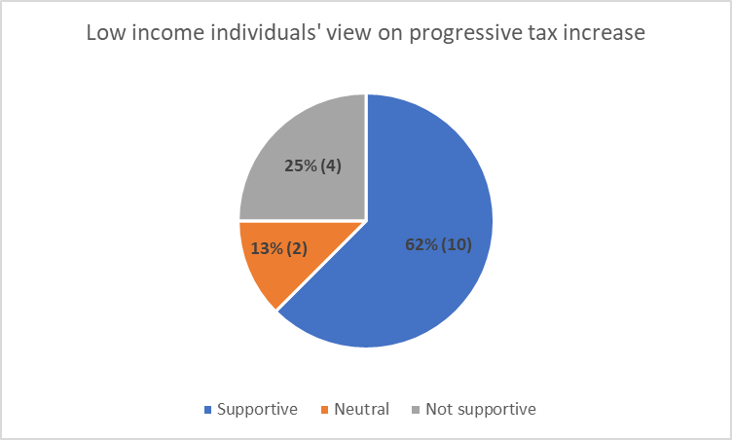
Figure 1
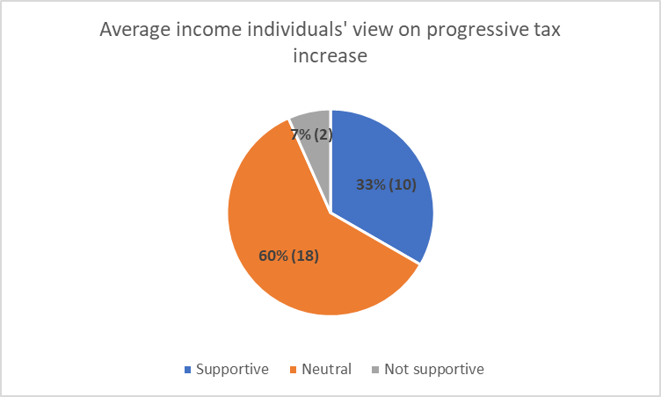
Figure 2
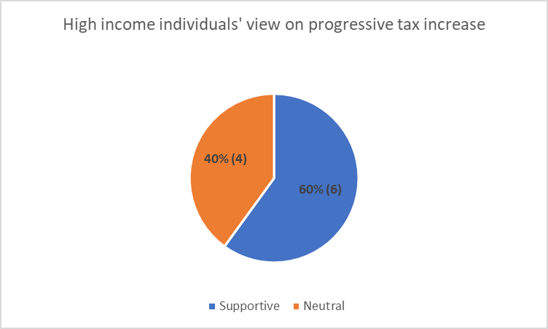
Figure 3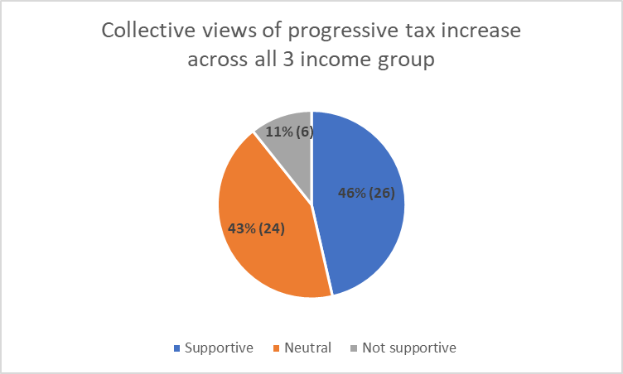
Figure 4

Results of surveys regarding the implementation of progressive tax increase were grouped according to the respondents’ income status as shown in Figure 1, 2 and 3. A total of 56 responses were recorded, with 16 respondents from low-income, 30 from average income, and 10 from high-income households.
From Figure 1, low-income group individuals were largely supportive of a tax increase, with 62% of respondents providing positive feedback. This could be due to the provision of benefits that could ease their financial burdens, such as cheaper healthcare and education. The remaining 38% of respondents were not as supportive, due to concerns of having to pay more tax, which could further strain their already limited resources. As for the average income group, only 33% of the respondents were supportive of the tax increase (Figure 2). A huge proportion of respondents from the average income group were neutral to the idea of increasing taxes. While the tax increase does aid in reducing income inequality, there were concerns raised by the middle to lower-income groups due to worries that tax increases may result in greater financial burden. This may outweigh the benefits the tax increase would have brought. High-income individuals were overall willing to accommodate the tax increase, with 60% supportive of the idea, and the remaining neutral (Figure 3). They mentioned that the tax increase is acceptable, provided that the money was well-utilised.
In general, the increase of progressive tax was mostly well received by all (Figure 4) with 46% of responses being supportive of the increase, and 43% being indifferent to it. Only a small fraction of respondents, from the middle to low-income group, were unsupportive of the increase, worrying that it might exacerbate financial burden. This suggests that imposing a progressive tax increase in the future will unlikely be met with a huge resistance, allowing the government to acquire more funds to assist the less fortunate.

Discussion
In an adaptation of Canada’s official poverty line, we seek to implement official tiered poverty lines using AHEBN as a baseline to assess the eligibility of citizens for financial benefits. In order to accurately gauge the boundaries of our system, we referenced Singaporean politician Jamus Lim’s speech during the parliamentary debate. According to Lim, the unofficial poverty line in Singapore was $1900 per household (Hana, 2020). Factoring in inflation rates, the lowest poverty line we will be implementing is $2100 per household. The following tiers are between $2101-$2300, $2301-$2500, $2501-$2700 and $2700-2900 accordingly (Figure 5).

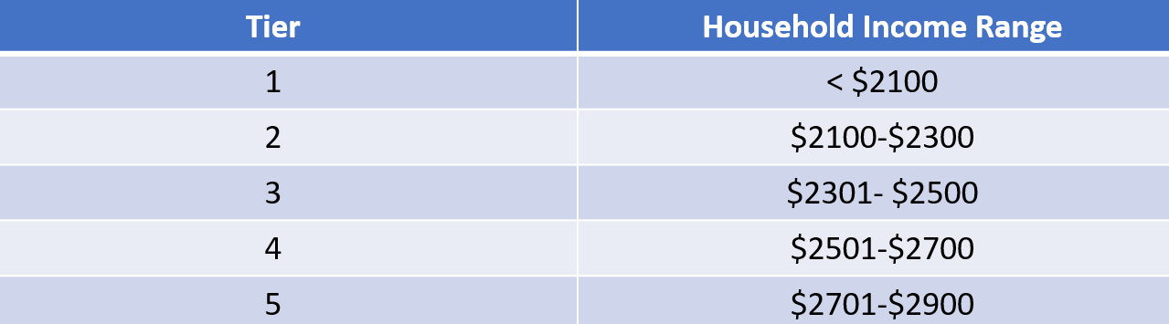
Figure 5

The current SkillsFuture Scheme will be fine-tuned to utilise a tiered credit system. Currently, all citizens above the age of 25 have a total of $1000 SkillsFuture credits (SkillsFuture Credit, n.d.). In our proposed solution, extra credits are given to citizens residing below the poverty lines. Citizens in Tier 1 would gain an additional $500, while Tiers 2 and 3 would receive an additional $400 and $300 respectively. Cash awards upon the completion of selected SkillsFuture courses would be tiered similarly.
Monetary pay-outs of unemployment benefits will also be tiered, with a starting benchmark of $70 per day for a duration of 6 months. These pay-outs are given to unemployed citizens who have completed SkillsFuture courses but have yet to secure a job. The government’s provision of such financial perks would act as an incentive for upskilling, encouraging citizens to enhance their employability.

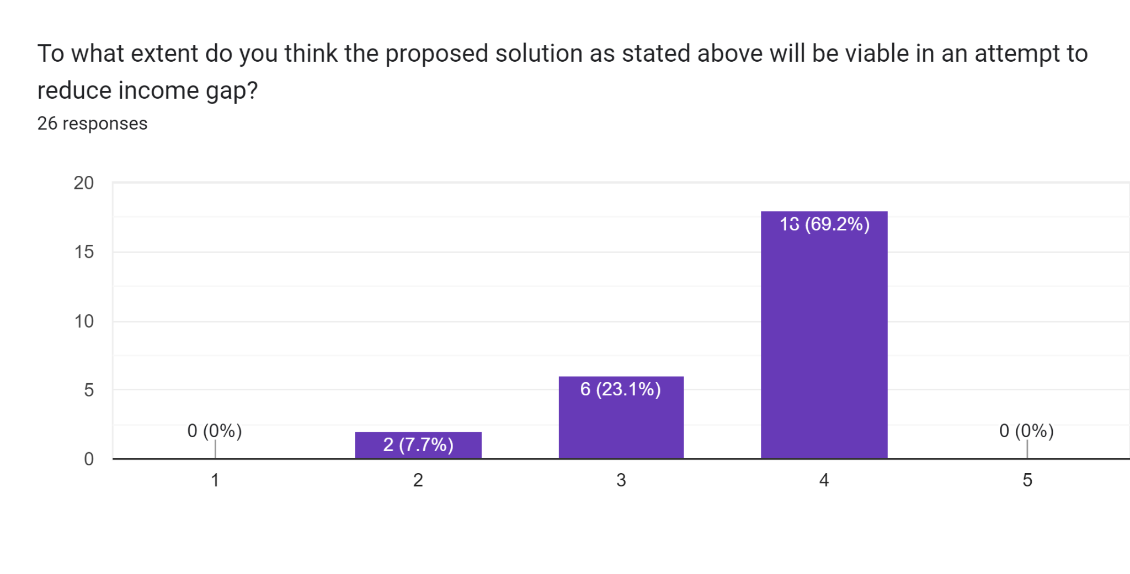
Figure 6

Survey results assessing the feasibility of the tiered poverty line largely reinforce the public receptiveness of our solution (Figure 6). However, it is essential to consider citizens in circumstances that these benefits might not be accessible to, such as individuals with disabilities, and those shouldering caregiver responsibilities. Respondents suggest the provision of hands-on work experiences similar to internships and work attachments through SkillsFuture to increase opportunities for networking. However, implementation of these benefits would require substantial financing. Fortunately, surveys conducted regarding the imposition of progressive tax increase were considerably well-received across the three income households as represented in the preceding section. This would provide the government with the necessary funding to execute the suggested remedy, allocating more resources to aid the needy in reducing the existing income gap.
In light of a rapidly changing business landscape, demand for jobs in different sectors have fluctuated, affecting job security. Facing greater technological advancement, employers in sunrise industries – defined as new and growing industries – are likely to be more inclined towards hiring workers equipped with more advanced technological skills. By tiering unemployment benefits and SkillsFuture credits, our solution wields the dual function of providing both financial support and opportunity for upskilling. Explicitly linking financial support to the completion of SkillsFuture courses incentivises unemployed individuals to enrol in courses and hone their skills, simultaneously enabling them to receive a daily pay-out to subsidise day-to-day expenses. Capping the duration of financial support reduces the likelihood of unemployed citizens growing reliant on government aid. In the same vein, the new skills they gain would ease their job search. In sum, our proposed solution would improve both the material and non-material standard of living for retrenched individuals. Furthermore, our proposed solution reduces the cost of upskilling while providing financial incentives, appealing to more citizens. With citizens equipped with more diverse and relevant skill sets, the likelihood of unemployment falls, increasing individual purchasing power. This in turn increases quantity demand for goods and services, and stimulates the economy, improving both individuals and the country’s economic situation.
Mirrored after Canada’s poverty line, Singapore’s official definition of poverty would similarly be an “act of political courage”. The introduction of an official poverty line has seen hesitation in governments across the world, as it is “as much a value judgement to be made, as a hard fact to be observed” (Corak, 2018), connoting plausible social implications. However, the official poverty line will hold the government to accountability, prompting greater transparency regarding the debate over “poverty”. This enables more productive discussions for poverty eradication and motivates closer scrutiny on the promised outcomes. The official poverty line therefore acts as a benchmark to which the public can track the country’s progress.

Limitations
Quoting from Prime Minister Lee Hsien Loong, “the poor [in Singapore] range from those going through temporary setbacks to families suddenly felled by illness, to the needy elderly and low skilled workers”, with “each [group needing] a different sort and scale of help”. In sum, the needy in Singapore take on a “multi-faceted form” (Chang, 2013), posing challenges to our solution. While the tiered poverty line, SkillsFuture credits and unemployment benefits cater to diverse groups through providing flexibility, there remains a tendency of inevitably side-lining outliers.

Conclusion / Implications
In essence, our proposed solution constitutes the tiering of a poverty line, SkillsFuture credits and unemployment benefits, with the latter meant to provide short-term aid. Together, they aim to ensure the less privileged receive the required resources to break out of the poverty cycle, heightening sustainability of the solution. Further, the three prongs prompt consistent tracking and updating by the government to ensure transparency and accountability. Ultimately, increased social mobility aids in reducing income inequality, bridging the gap between socio-economic classes, and creating a more cohesive society.
Word count: 2, 191

References
The Borgen Project. (2018, March 31). Poverty in Singapore. Retrieved November 13, 2022, from https://borgenproject.org/tag/poverty-in-singapore/#:~:text=Out%20of%20136%20countries%20considered,family%20homes%2C%20or%20378%2C000%20people.
Carter, V. J., &amp; Howard, M. W. (2016, July 14). Income inequality. Britannica. Retrieved November 15, 2022, from https://www.britannica.com/topic/income-inequality
Chang, R. (2013, January 20). PM: We don't need poverty line to help the poor. The Straits Times. Retrieved November 13, 2022, from https://www.straitstimes.com/singapore/pm-we-dont-need-poverty-line-to-help-the-poor
Corak, M. (2018, August 21). Canada's official poverty line: What is it? how could it be better? Economics for public policy. Retrieved November 14, 2022, from https://milescorak.com/2018/08/21/canadas-official-poverty-line-what-is-it-how-could-it-be-better/
Capital flight. Corporate Finance Institute. (2021, February 12). Retrieved November 14, 2022, from https://corporatefinanceinstitute.com/resources/economics/capital-flight/
Donaldson, J. A., Loh, J., Mudaliar, S., Kadir, M. M., Wu, B., & Lam, K. yeoh. (2013). Measuring Poverty in Singapore: Frameworks for Consideration. Ink.library.smu.edu.sg. Retrieved November 14, 2022, from https://ink.library.smu.edu.sg/cgi/viewcontent.cgi?article=1115&context=lien_research
Impacts. The Equality Trust. (n.d.). Retrieved November 13, 2022, fromhttps://equalitytrust.org.uk/about-inequality/impacts
Gouvernement du Canada. (2022, April 20). Canada's First Poverty Reduction Strategy. Canada.ca. Retrieved November 14, 2022, from https://www.canada.ca/en/employment-social-development/programs/poverty-reduction/reports/strategy.html
Hana, O. (2020, September 8). Jamus Lim calls for official poverty line in s'pore to be established - singapore news. The Independent Singapore News. Retrieved November 14, 2022, from https://theindependent.sg/jamus-lim-calls-for-official-poverty-line-in-spore-to-be-established/
Holzer, H. J. (2022, March 19). Understanding the impact of automation on workers, jobs, and wages. Brookings. Retrieved November 14, 2022, from https://www.brookings.edu/blog/up-front/2022/01/19/understanding-the-impact-of-automation-on-workers-jobs-and-wages/
Kopp, C. M. (2021, November 2). Income inequality definition: Examples and how it's measured. Investopedia. Retrieved November 14, 2022, from https://www.investopedia.com/terms/i/income-inequality.asp
Improving the lives of low income and vulnerable families in Singapore. Ministry of Social and Family Development. (2018, November). Retrieved November 14, 2022, from https://www.msf.gov.sg/publications/Documents/Improving%20the%20lives%20of%20low-income%20and%20vulnerable%20families%20in%20Singapore.pdf
MySkillsFuture. (n.d.). Retrieved November 14, 2022, from https://programmes.myskillsfuture.gov.sg/QualificationAward/ProgrammeDetails.aspx#:~:text=Singaporean%20workers%20who%20attain%20a,attainment%20of%20your%20WSQ%20qualification
Skillsfuture credit. SSG | SkillsFuture Credit. (n.d.). Retrieved November 13, 2022, from https://www.skillsfuture.gov.sg/credit
Sweden - Unemployment benefits. Sweden - Employment, Social Affairs & Inclusion - European Commission. (n.d.). Retrieved November 14, 2022, from https://ec.europa.eu/social/main.jsp?catId=1130&langId=en&intPageId=4817#:~:text=Unemployment%20benefits%2C%20whether%20paid%20from,to%20an%20additional%20150%20days
Tham, S., & Khanh, D. H. V. (2016, June 14). Survey of fairness perceptions in Singapore public policy. CSC. Retrieved November 14, 2022, from https://www.csc.gov.sg/articles/survey-of-fairness-perceptions-in-singapore-public-policy
United Nations. (n.d.). REDUCED INEQUALITIES: WHY IT MATTERS. Retrieved November 14, 2022, from https://www.un.org/sustainabledevelopment/wp-content/uploads/2018/01/10_Why-It-Matters-2020.pdf

Appendix A

Survey questionnaire regarding implementation of tax increase
Background (Please read)
Scandinavian countries, such as Sweden, has had a low Gini coefficient (statistical measurement for income inequality) for a long time coming. This is due to a collective effort from the public in support of the high tax policies. The tax money paid is then directed towards free education (including tertiary studies), heavily subsidized healthcare, childcare benefits, along with pension and elderly care.
Benefits: Free education: Mandatory free education provided by the states, including university studies
Healthcare: High quality healthcare averaged at around $35, with a cap if expenses are too high
Childcare: $160/month paid to parents and an additional 480 paid paternal leaves for every conceived child
Elderly care: High pension and flexible retirement age, above age of 62.

This survey is aimed to find out how university students feel about increasing progressive tax in the future in exchange for said benefits, in an attempt to reduce the income gap.

1. Which university are you from?

2. What is your gender?

3. What is your family income status?

4. Are you aware of the benefits from high tax policies?

5. How do you feel about increasing progressive tax rate in Singapore? (Assuming benefits gained are comparable to those in Sweden)

6. Please elaborate the reasons for your previous response.

Link to survey: https://forms.gle/LXRysmUmx3y1hkMNA

Appendix B
Survey questionnaire regarding proposed solution to combat income inequality in Singapore.
Context
Singapore's Gini coefficient index, as of 2021, sits at around 0.39. Despite the government's effort in implementing policies to reduce the income gap, the income difference is still quite considerable among the different socioeconomic classes.

The aim of this survey is to determine the viability of our proposed solution, in an attempt to reduce the gap.

Solution
As of now, Singapore does not have an official poverty line. Therefore, We propose to adopt a tiered poverty bracket* in Singapore based on citizen's Average Household Expenditure on Basic Needs (AHEBN).

*Having different sub poverty classes with different income (E.g. tier 1: below 2k earnings, tier 2: below 1.8k earnings, tier 3: below 1.5k earnings, etc.)

1) Utilizing skillsfuture, those of lower tier would get more completion money.
2) Provided to those attending skillsfuture, additional cash benefit on top of completion money to compensate for their time (capped at $8/hr and $70/day). 6 months of cooldown period upon completion of course, before benefits can be applied again.

Amount of cash benefit received will be based on poverty tier.

Goal
1) Encourage people under poverty/unemployed to upskill themselves, by providing them with the national minimum average part-time salary ($8) while allowing for more work opportunities.
2) Implementation of a tiered poverty class such that everyone within a range of income gets access to the benefits.

1. To what extent do you think the proposed solution as stated above will be viable in an attempt to reduce income gap?

2. Please elaborate on your previous response.

Link to survey: https://forms.gle/m5r6H7mSrBmfiVKT9

